An Abstract Template for PSM2010

Y. Shibayama,¹ H. Fukuyama,² and K. Shirahama¹

¹Dept. of Physics, Keio University, 3-14-1 Hiyoshi, Kohoku-ku, Yokohama-shi, Kanagawa 223-8522, Japan
²Department of Physics, The University of Tokyo, 7-3-1 Hongo, Bunkyo-ku, Tokyo 113-0033, Japan

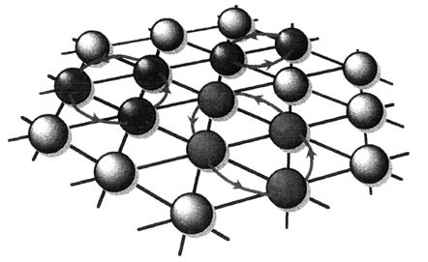
This is a template showing abstract format for the PSM2010. Abstract files (only of the Microsoft Word “.doc” format) can be submitted through the Abstract Submission page of PSM2010 website:
FIG.1: Sample of figure and figure caption.

http://kelvin.phys.s.u-tokyo.ac.jp/psm2010/abs.html
after creating your own account at the Registration page:
https://kelvin.phys.s.u-tokyo.ac.jp/psm2010/reg.html.
Use your name and version number for the abstract file name like, “y_shibayama_v1.doc”. The deadline for abstract submission is January 31, 2010.
The length of abstract should be less than one page of A4 size. The margins of each page are 25 mm for four sides. The recommended font is Times New Roman. The font size should be 14 pt for title, 12 pt for author names, 10 pt (italic) for authors’ affiliations, 11 pt for main text and 10 pt for references and figure captions. The references and figures are cited like [1] or (Fig.1) in the text.
Abstracts will be uploaded in original colors on the website, while they will be printed in black and white in the booklet.

[1] Y. Shibayama et al., J. Phys. 150, 032096 (2009).

